***Model of a sailboat in a glass bottle***

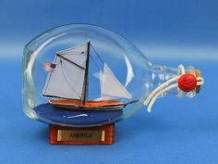

*Sailboat model in a glass bottle measures 24 cm in length, 11 cm in height. The product is carefully packed to avoid breakage during transit. The product includes a wooden base, a glass bottle inside with a hand-crafted glass sailboat model. The model of a sailboat in a glass bottle is suitable for a boss, a gift for parents, a birthday gift for a boyfriend, etc.*